Wisconsin Polka Booster
Fall Dance

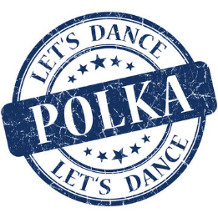

Who: Anyone who wants to enjoy some fantastic music-everyone is welcome!
We will have registration forms available if you would like to join the Wisconsin Polka Boosters or renew your membership!

When: Sunday, October 11, 2026

Where: VFW New Berlin, 17980 Beloit Rd, New Berlin, WI 53146

Time: Doors open at 12:30pm, with music from 1-5:00pm

Cost: $10 admission. Cash bar.

Entertainment: We are thrilled to have music from Carol & the Keynotes and a cash raffle!

Questions? Contact WPB Board Secretary/Queen Lisa Hare at 414-940-0080

We look forward to seeing you!
______________________________________________________________

If you can’t make it, but would like to make a donation to our annual college scholarship, please make out a check to Wisconsin Polka Boosters and send it to 4421 S. 49th St, Greenfield WI 53220. Thank you for your support!

501-3(c) non-profit organization
Check us out online! www.wipolkaboosters.com

